

# Practices for Secure Software Report

Table of Contents

Document Revision History 3

Client 3

Instructions 3

Developer 4

1. Algorithm Cipher 4

2. Certificate Generation 4

3. Deploy Cipher 4

4. Secure Communications 4

5. Secondary Testing 4

6. Functional Testing 4

7. Summary 4

8. Industry Standard Best Practices 4

## Document Revision History

| **Version** | **Date** | **Author** | **Comments** |
| --- | --- | --- | --- |
| **1.0** | **10/18/2023** | **Justin Murray** | **Completed initial review of document** |

## Client



## Instructions

Submit this completed practices for secure software report. Replace the bracketed text with the relevant information. You must document your process for writing secure communications and refactoring code that complies with software security testing protocols.

* Respond to the steps outlined below and include your findings.
* Respond using your own words. You may also choose to include images or supporting materials. If you include them, make certain to insert them in all the relevant locations in the document.
* Refer to the Project Two Guidelines and Rubric for more detailed instructions about each section of the template.

## Developer

Justin Murray

## Algorithm Cipher

Since Artemis Financial is a company working with customers money and financial futures it is important they have some of the best encryption protocols available to help protect their clients assets and information. Any attack or intercepted information could be devastating to the client or reputation of our company. I feel like Sha-256 would be an acceptable encryption to use because it is one of the more difficult key encryptions and its use of random key combinations makes it so that it has a nonreversible check to it.

## Certificate Generation

Insert a screenshot below of the CER file.

## Deploy Cipher

Insert a screenshot below of the checksum verification.

[Insert screenshots here.]

## Secure Communications

Insert a screenshot below of the web browser that shows a secure webpage.

## Secondary Testing

Insert screenshots below of the refactored code executed without errors and the dependency-check report.

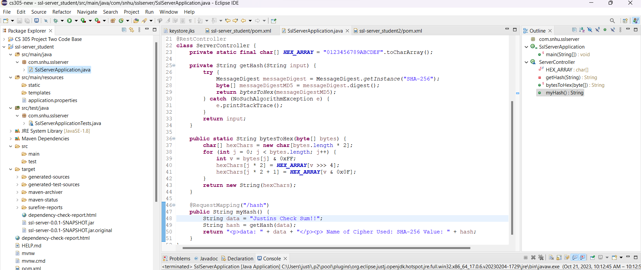

## Functional Testing

Insert a screenshot below of the refactored code executed without errors.

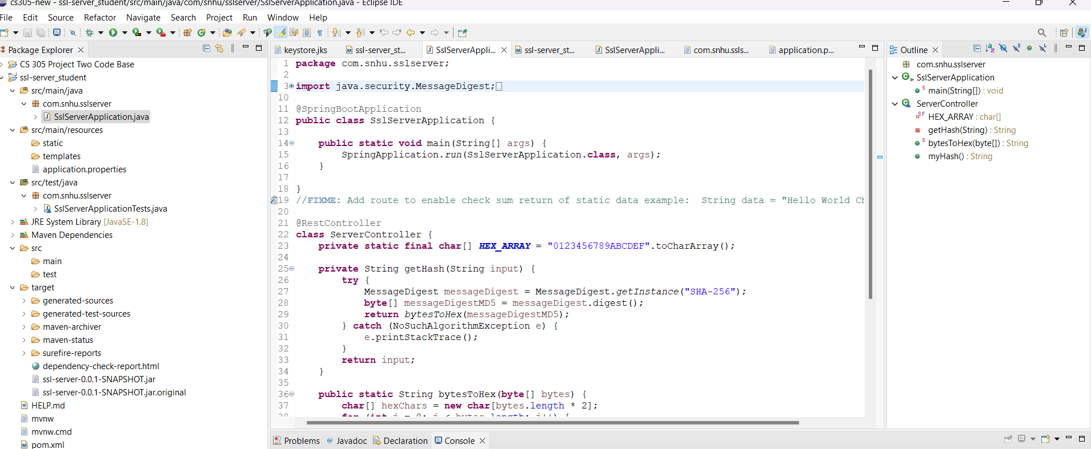

## Summary

In order to get the code working properly we had to refactor a few parts of the code like updating the dependency version to 8.4 adding a secured rest controller to watch and secure the programs hash restful stops. In order to keep up with the maintenance of the system the dependency check should be ran at least twice a month as well as making sure to keep firmware updated.